**FUNCTIONAL AND TECHNICAL COMBINED DOCUMENTATION**

**Page (29): Company Details (Front End Url:** http://localhost:8100/page29/Page29)

**Functional Picture:**

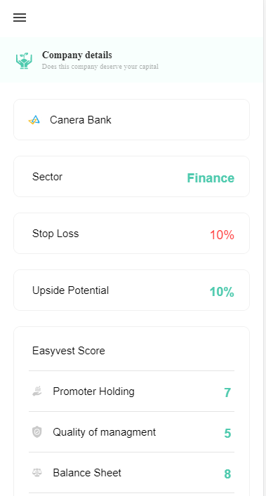

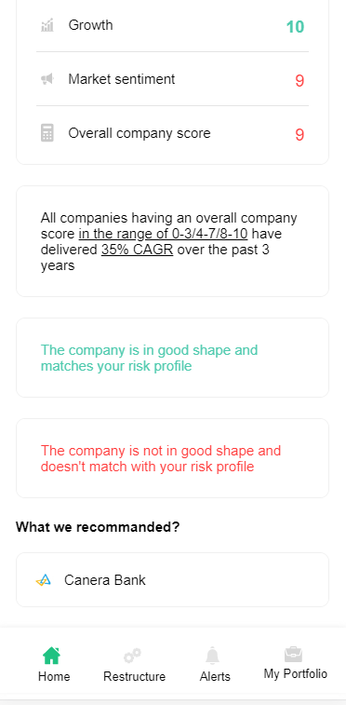

**In this Page, the user is going to see the list of fundamental details of the stocks that the user has in his portfolio.**

**Technical Explanation (Front End and Back End):**

**In Page29.tsx, we are calling following 1 API:**

1. SearchCompanyDetailsAPI: see backend python file. In this we are doing GET requests.

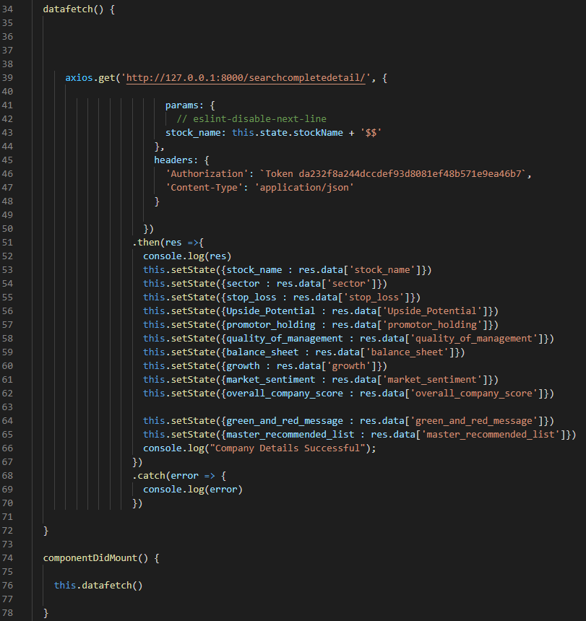

**As you can see, we are calling the** SearchCompanyDetailsAPI

**using this url:** [**http://127.0.0.1:8000/searchcompletedetail/**](http://127.0.0.1:8000/searchcompletedetail/)**. In this we are taking the fundamental analysis data of the stock.**

**Kindly see the given below backend Code for this GET request.**

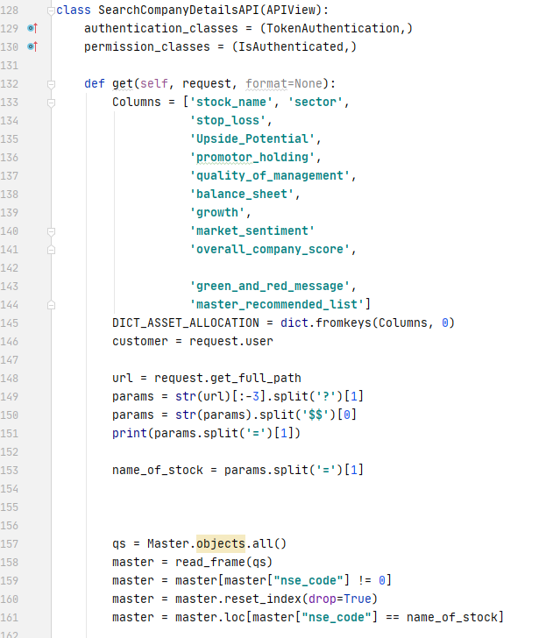

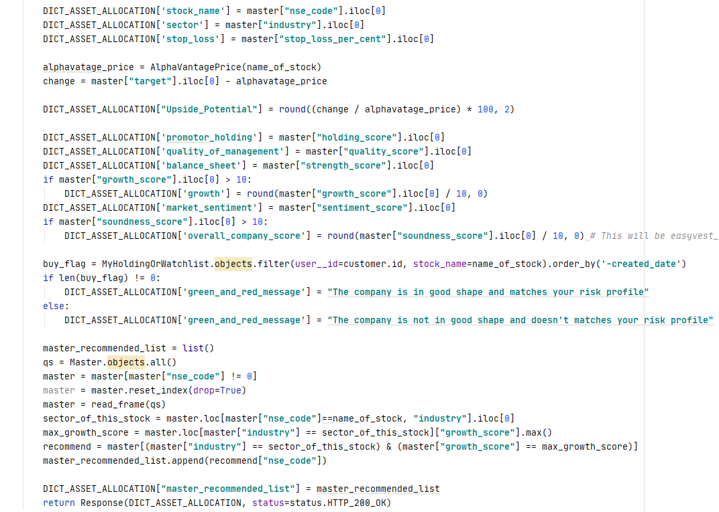

**The Above API is using the MyHoldingOrWatchlist Database.**

**Along with this we are also showing its stoploss and upside potential. Kindly see** SearchCompanyDetailsAPI in searchandcomapanydetails.py in the backend

**DONE!!!**